SARHAD UNIVERSITY (SUIT), PESHAWAR



Project: Student Mangnment System
SUBJECT:: Programming for Ai
SUBMITTED BY: : Muhammad Ismail
REG NO :: SU-24-01-001-054
SEMESTER :: 3rd CS-2
SECTION:: 02
Department: Computer Science & IT
SUBMITTED TO:: Mr.Muhammad Junaid

1. Introduction
The Student Record Management System is a software application developed to manage student information efficiently. In many schools and colleges, student records are still handled manually, which can lead to errors and difficulty in managing large amounts of data.
This project is developed using Python programming language with Tkinter for the graphical user interface (GUI) and MySQL database for storing student records. The application allows users to add, search, update, display, and delete student records easily.
The system connects Python with a local MySQL server using the PyMySQL library, and the database is managed using MySQL Workbench.

2. Objectives of the Project
The main objectives of this project are:
To develop a GUI-based Student Management System.
To store and manage student records using a MySQL database.
To connect Python with MySQL using database connectivity.
To perform basic database operations such as insert, update, delete, and search.
To simplify the management of student information.

Tools and Technologies Used

Tool / Technology | Purpose
Python | Main programming language
Tkinter | GUI library used to create the interface
MySQL | Database used to store student records
PyMySQL | Library used to connect Python with MySQL
VS Code | Code editor used to develop the program
MySQL Workbench | Tool used to manage the MySQL database

4. System Architecture
The system works in three main layers:

1. User Interface (GUI)
The graphical interface is created using Tkinter. It allows users to interact with the system through buttons and input fields.

2. Application Layer
The Python program processes user input and sends SQL queries to the database.

3. Database Layer
The MySQL database stores all student information in tables.
Flow of System
User → Tkinter Interface → Python Program → MySQL Database → Result Display

5. Database Design

Database Name --> school

Table Name --> student

Table Structure
Field | Data Type | Description
rollNo | INT | Unique roll number of student
name | VARCHAR | Student name
fname | VARCHAR | Father name
sub | VARCHAR | Subject
grade | VARCHAR | Student grade
This table stores all the information about students.

6. User Interface Description
The system contains two main sections:

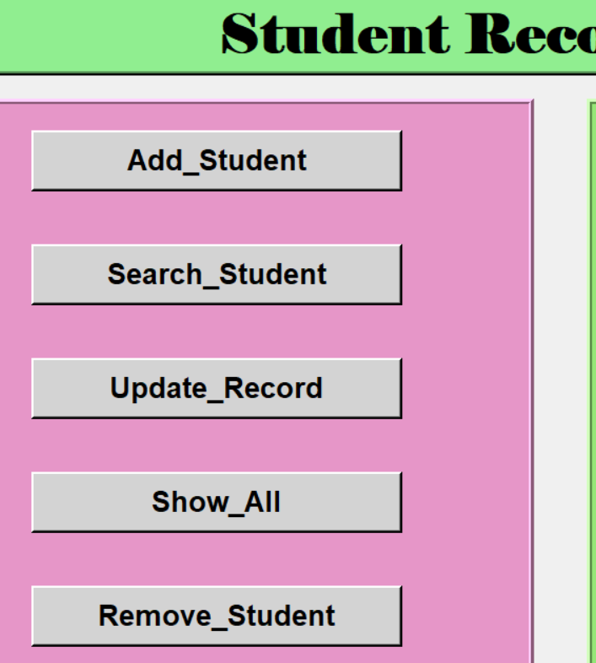
Option Panel
Contains buttons for different operations:
Add Student
Search Student
Update Record
Show All
Remove Student

Record Details Panel
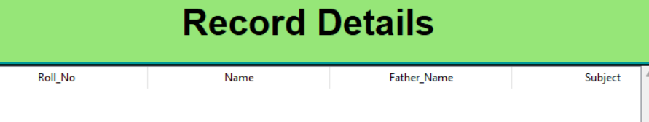
Displays student records in a table format using Treeview.

7. Features of the System
The system provides the following functions:

1. Add Student
This feature allows the user to add a new student record into the database.
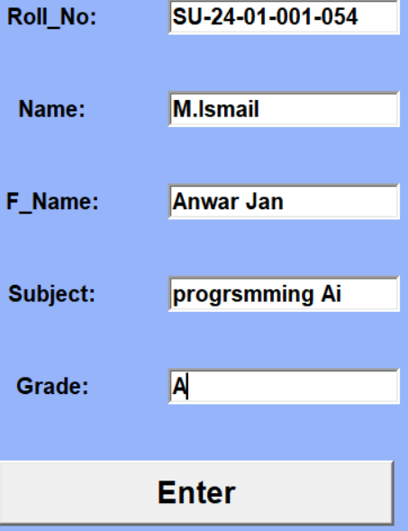
The user enters:
Roll Number
Name
Father Name
Subject
Grade
The data is stored in the MySQL database.

2. Search Student
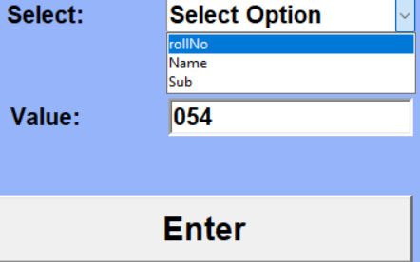
This feature allows users to search student records using different fields such as:
Roll Number
Name
Subject
The system retrieves the matching record from the database and displays it in the table.

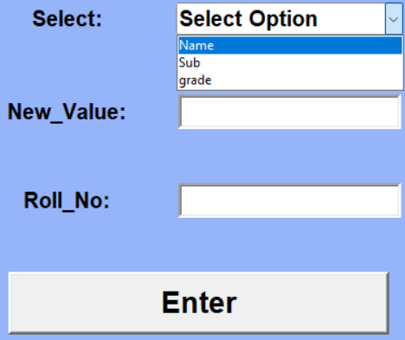
3. Update Student Record
This option allows the user to update
existing student information such as:
Name
Subject
Grade
The update is performed using the student’s roll number.

4. Show All Records
This feature displays all student records stored in the database in a table view.
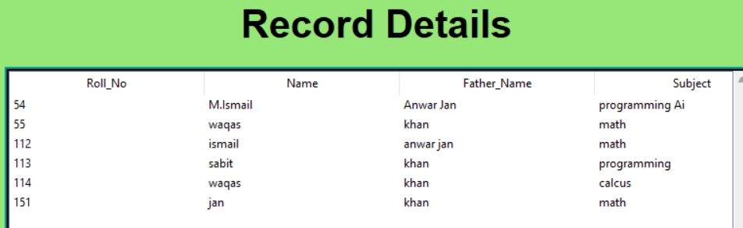
The records are displayed using Treeview widget in Tkinter.

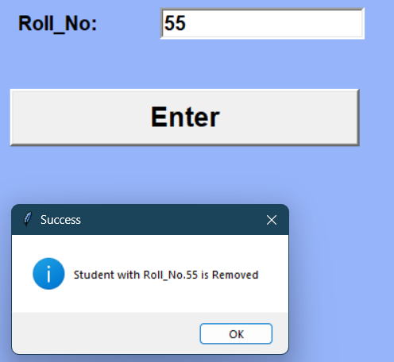
5. Delete Student Record
This feature allows the user to remove a
student record from the database using
the roll number.
The selected record is permanently
deleted from the database.

8. Database Connectivity
The connection between Python and MySQL is established using the PyMySQL library.
Example connection used in the project:
self.con = pymysql.connect(
host="localhost",
user="root",
passwd="mysql@9295",
database="school"
)
Steps used for database operations:
- Connect to MySQL server
- Create cursor object
- Execute SQL query
- Commit changes
- Close the connection

9. Advantages of the System
Easy to use graphical interface
Fast data storage and retrieval
Reduces manual record keeping
Organized student data management
Supports multiple database operations

10. Limitations
Only basic student information is stored
No login authentication system
Runs only on local machine
Not connected to a web server

11. Future Improvements
The system can be improved by adding:
Login authentication for security
Attendance management
Marks and result management
Web-based interface using Django or Flask
Cloud database storage
Student photo and profile management

12. Conclusion
The Student Record Management System successfully demonstrates how Python can be integrated with MySQL to manage student records. The application provides an easy-to-use graphical interface for performing various database operations such as adding, searching, updating, and deleting student records.
This project improves understanding of GUI development, database connectivity, and SQL operations, making it a useful learning experience in database-driven application development.

13. System Screenshots
This section shows the working interface of the Student Record Management System and the database used to store student information.

13.1 Python Program in VS Code
This screenshot shows the Python code of the Student Record Management System written in Visual Studio Code. The program is developed using Python, Tkinter for GUI, and PyMySQL for database connectivity.
Screenshot:
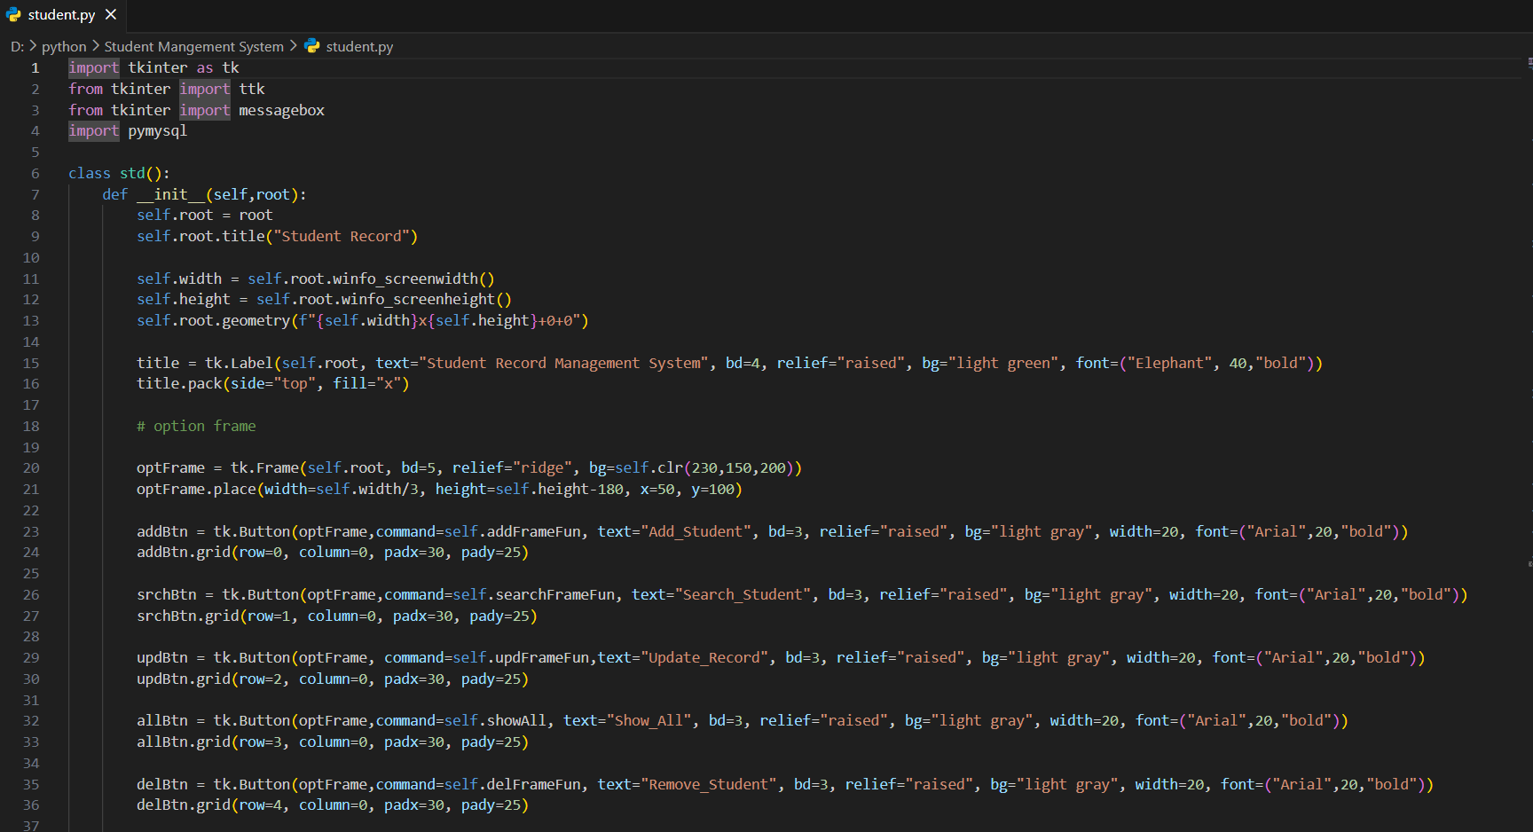

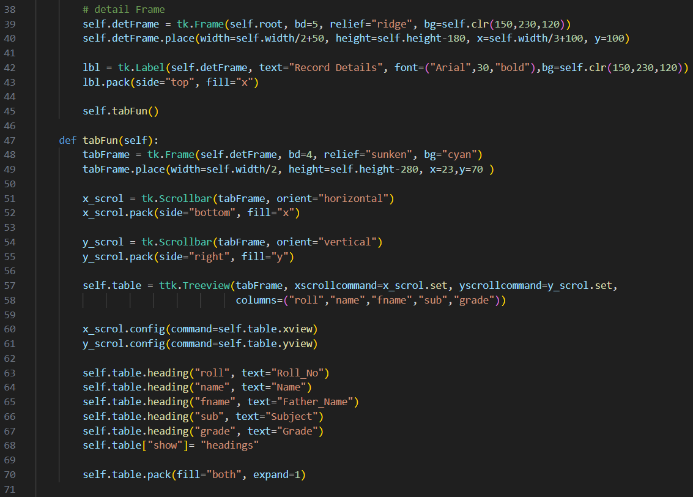
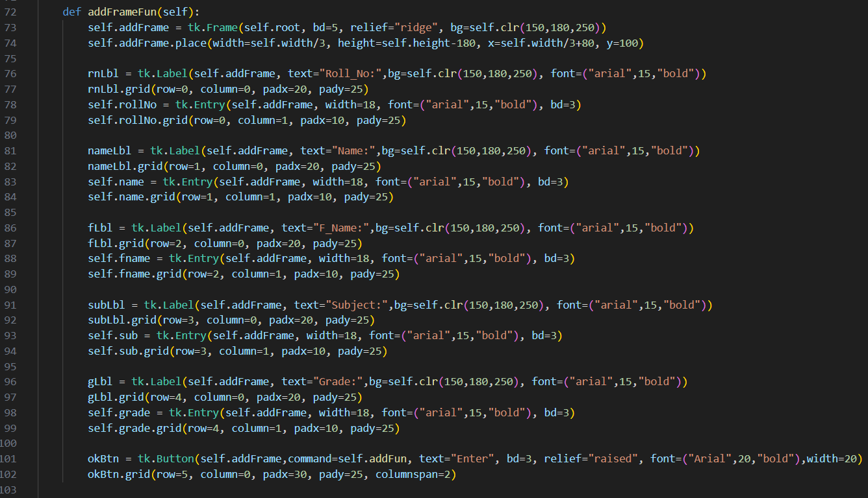
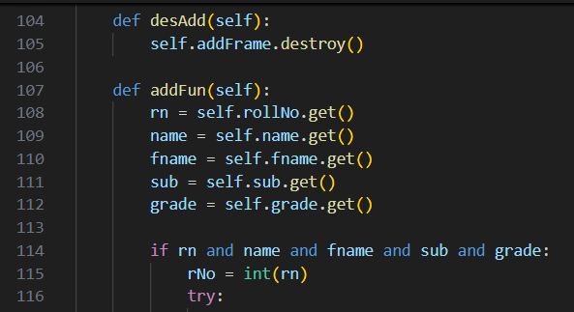
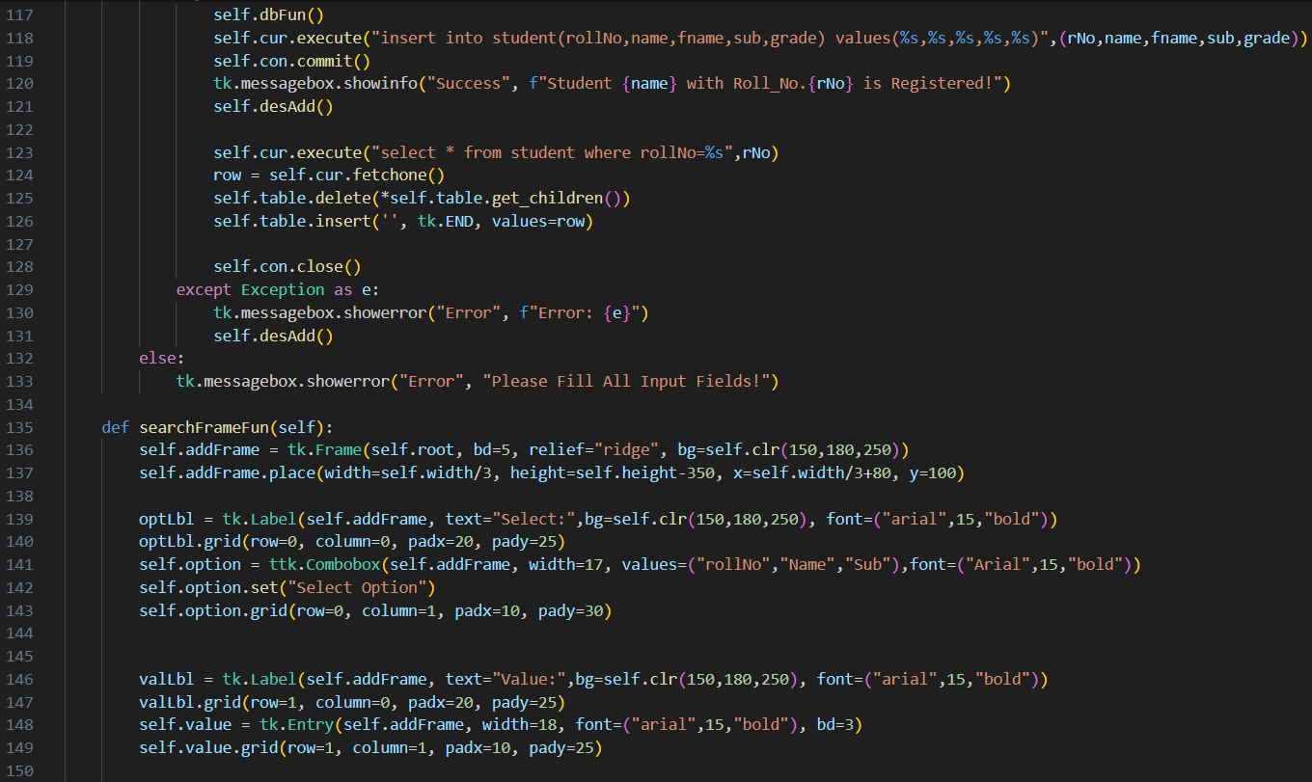

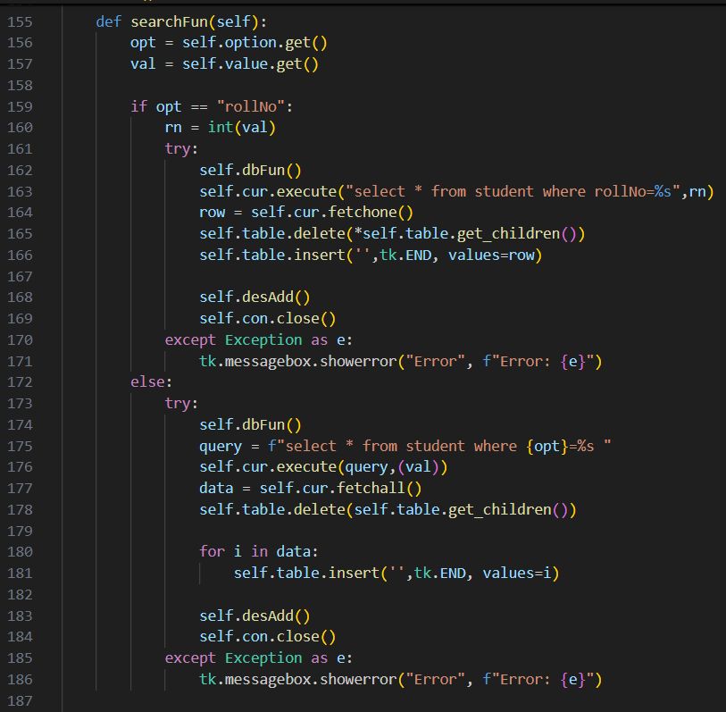
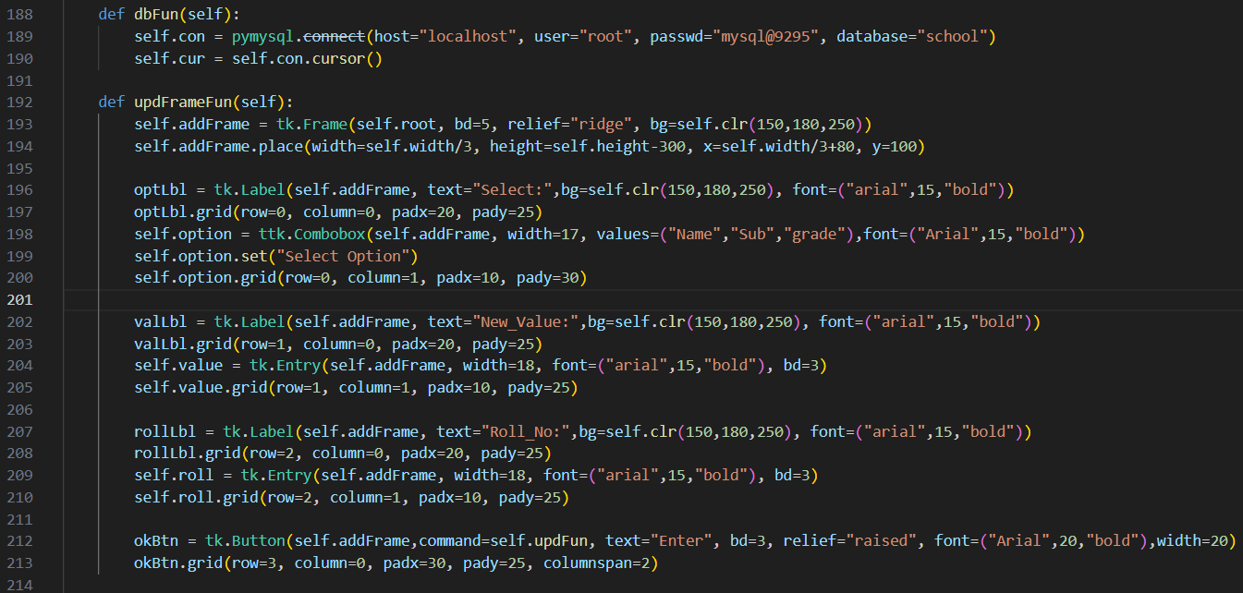
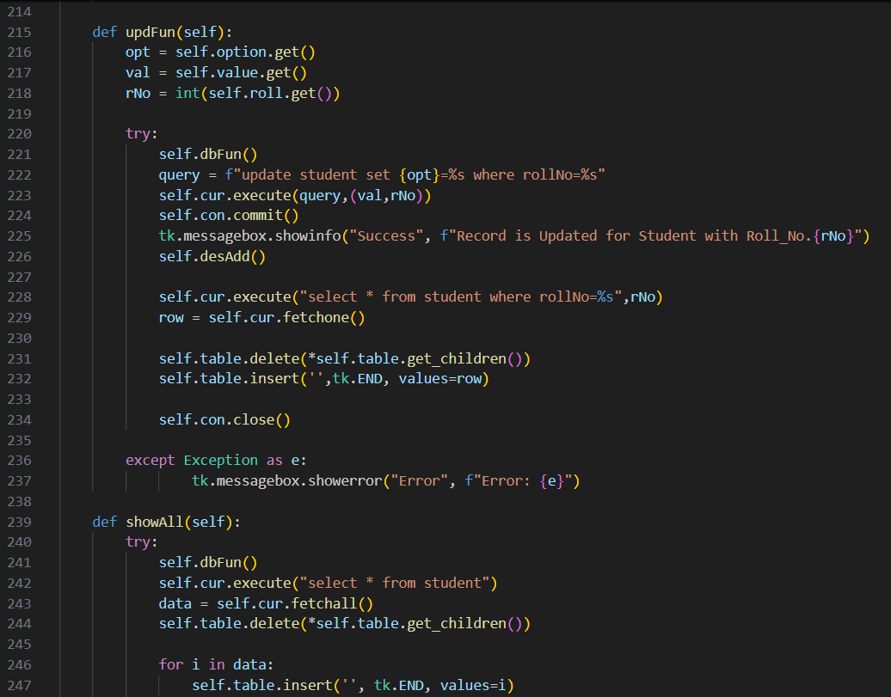

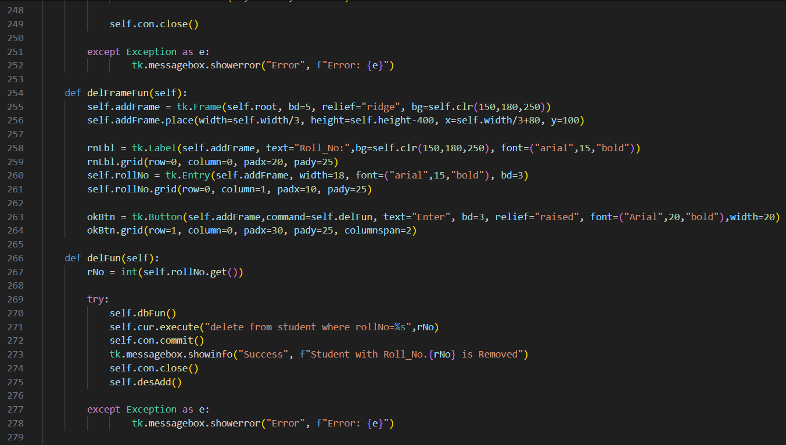
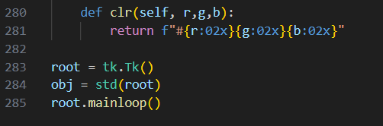

13.2 Main Interface of the System (GUI)
This screenshot shows the main graphical user interface of the system created using Tkinter. The interface contains different buttons such as:
Add Student
Search Student
Update Record
Show All
Remove Student
It also contains a table to display student records.
Screenshot:
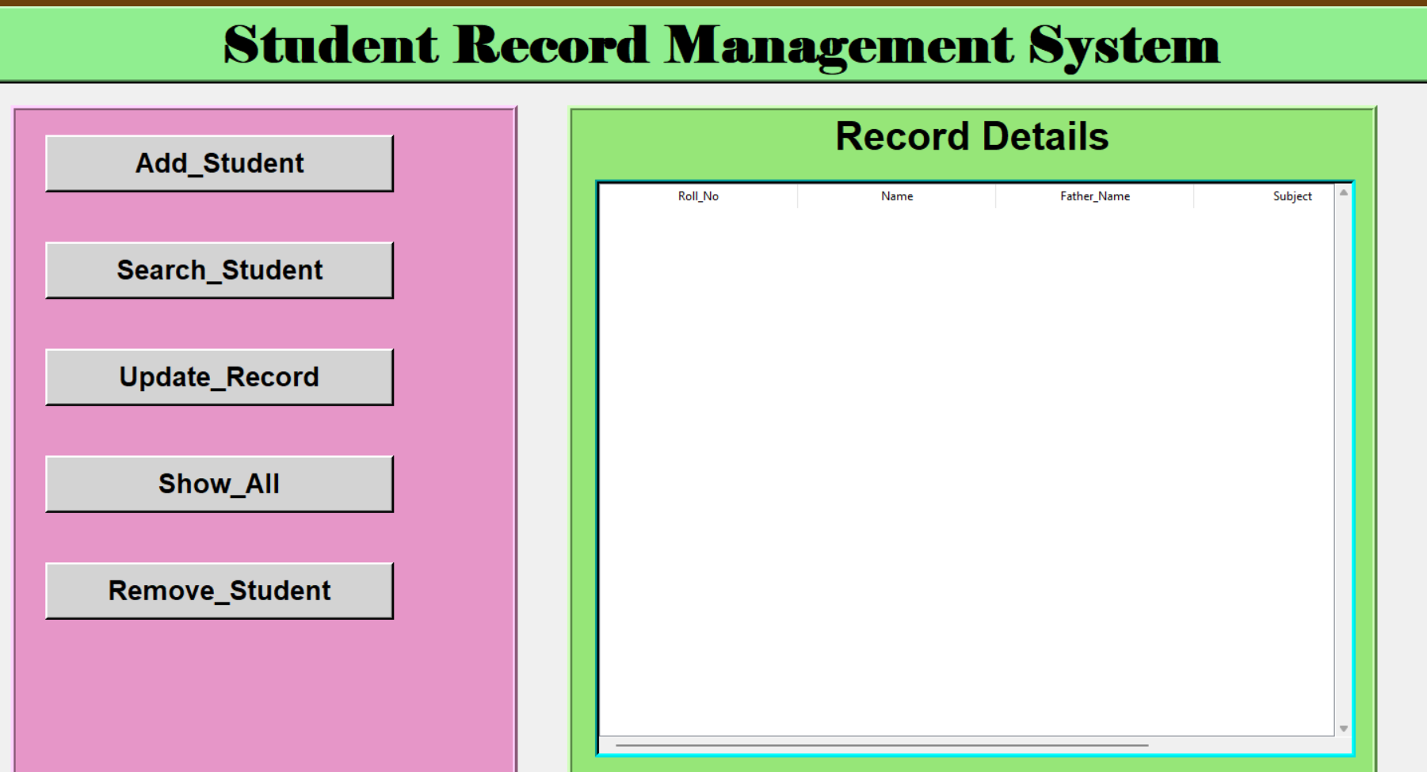


13.3 Add Student Window
This screen allows the user to enter new
student information such as:
Roll Number
Name
Father Name
Subject
Grade
After entering the information, the user
clicks the Enter button to store the record in the database.

13.4 Displaying Student Records
This screenshot shows how the system displays student records in a table format using Tkinter Treeview widget. The table contains the following columns:
Roll Number
Name
Father Name
Subject
Grade
Screenshot:
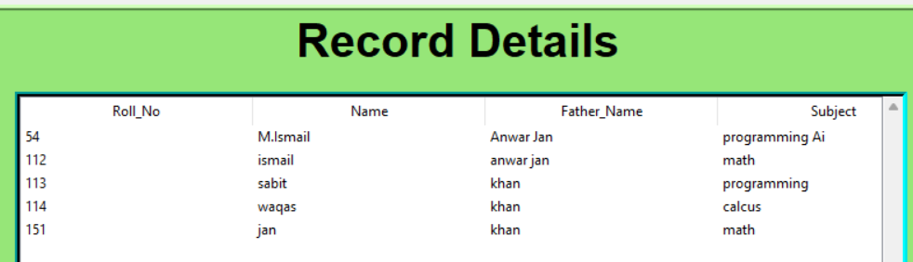

13.5 MySQL Database Table (MySQL Workbench)
This screenshot shows the student table in the MySQL database created using MySQL Workbench. The table stores all student records entered through the application.
Table fields include:
rollNo
name
fname
sub
grade
Screenshot:
